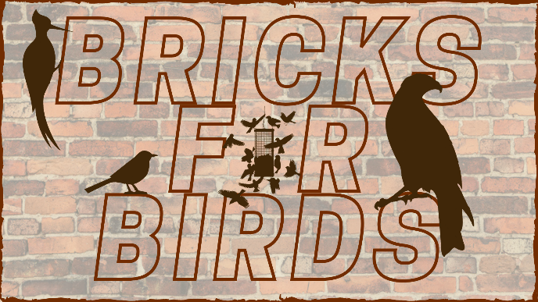
Bricks for Birds Order Form
□ 4” x 8” Text Only Brick
□ 8” x 8” Text Only Brick
□ 4” x 8” Text/Graphic Brick
□ 8” x 8” Text/Graphic Brick
Contact Information
Name ______________________________________________________________
Address _____________________________________________________________
City, State, Zip ________________________________________________________
Telephone _______________________________________
Email Address________________________________________________

Billing Information (If different than above)
Name_______________________________________________________________
Address _____________________________________________________________
City, State, Zip ________________________________________________________
Telephone _______________________________________
Email Address________________________________________________
Payment
Payment for your brick can be made by cash, check or credit card. If you would like to pay by credit card, please stop into the Nature Center or call us at 319-277-2187. Please make checks out to “Black Hawk County Conservation”. In the Memo line, please write “Bricks for Birds”. Your brick order will not be processed until payment is received.
Hartman Reserve Nature Center
Black Hawk County Conservation
657 Reserve Drive
Cedar Falls, Iowa 50613

Graphic Options for Text/Graphic Bricks
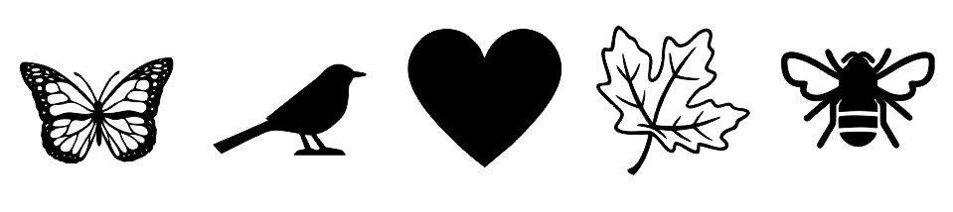

Text Only Bricks

4” x 8” Brick Inscription ($75)
Please print one letter per box. Spaces count as a character. Bricks will be engraved with what is put in the boxes below. 15 characters per line.
[___]___]___]___]___]___]___]___]___]___]___]___]___]___]___]
[___]___]___]___]___]___]___]___]___]___]___]___]___]___]___]
[___]___]___]___]___]___]___]___]___]___]___]___]___]___]___]
8” x 8” Brick Inscription ($125)
Please print one letter per box. Spaces count as a character. Bricks will be engraved with what is put in the boxes below. 15 characters per line.
[___]___]___]___]___]___]___]___]___]___]___]___]___]___]___]
[___]___]___]___]___]___]___]___]___]___]___]___]___]___]___]
[___]___]___]___]___]___]___]___]___]___]___]___]___]___]___]
[___]___]___]___]___]___]___]___]___]___]___]___]___]___]___]
[___]___]___]___]___]___]___]___]___]___]___]___]___]___]___]
[___]___]___]___]___]___]___]___]___]___]___]___]___]___]___]

Text & Graphic Bricks

4” x 8” Graphic Brick Inscription ($100)
Please print one letter per box. Spaces count as a character. Bricks will be engraved with what is put in the boxes below.

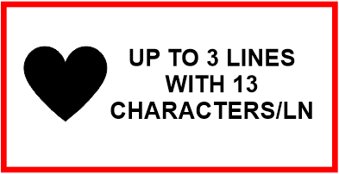
[___]___]___]___]___]___]___]___]___]___]___]___]___]
[___]___]___]___]___]___]___]___]___]___]___]___]___]
[___]___]___]___]___]___]___]___]___]___]___]___]___]

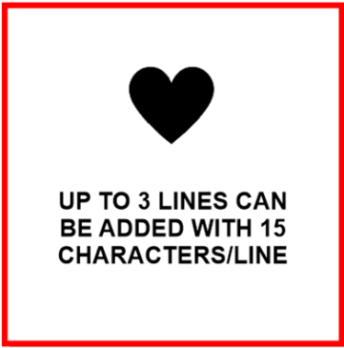
8” x 8” Graphic Brick Inscription ($175)
Please print one letter per box. Spaces count as a character.
Bricks will be engraved with what is put in the boxes below.
UP TO 3 LINES CAN BE ADDED WITH 13 CHARACTERS/LINE
[___]___]___]___]___]___]___]___]___]___]___]___]___]
[___]___]___]___]___]___]___]___]___]___]___]___]___]
[___]___]___]___]___]___]___]___]___]___]___]___]___]

Please check which graphic you’d like on your brick (choose one): □ Heart □ Butterfly □ Bee □ Leaf □ Bird

